Summerside PEI, Canada
May 2023

Professional & Vocational Education Support in Mozambique
It’s a joy to be able to continue to update you—our ministry partners—on the progress of our Mozambique Project.
We continue to support many younger children…most now in secondary school. But our primary focus is on post-secondary training and education to help position a few older youth to walk into the fullness of God’s Jer. 29:11 promise of “hope and a future.”
Recent Graduates
Our last report listed those who had successfully completed programs last year. More recently, Sabina Jovenito and Latifo Ahate have completed the police training program at the academy in Matalane, near the capital city of Maputo. And we anticipate that Nelson Ribeiro and Janete Virgilio will also enter this program in the very near future.
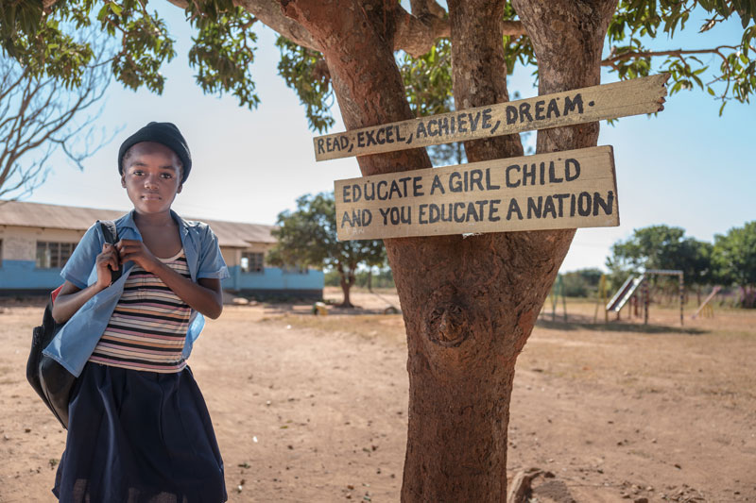
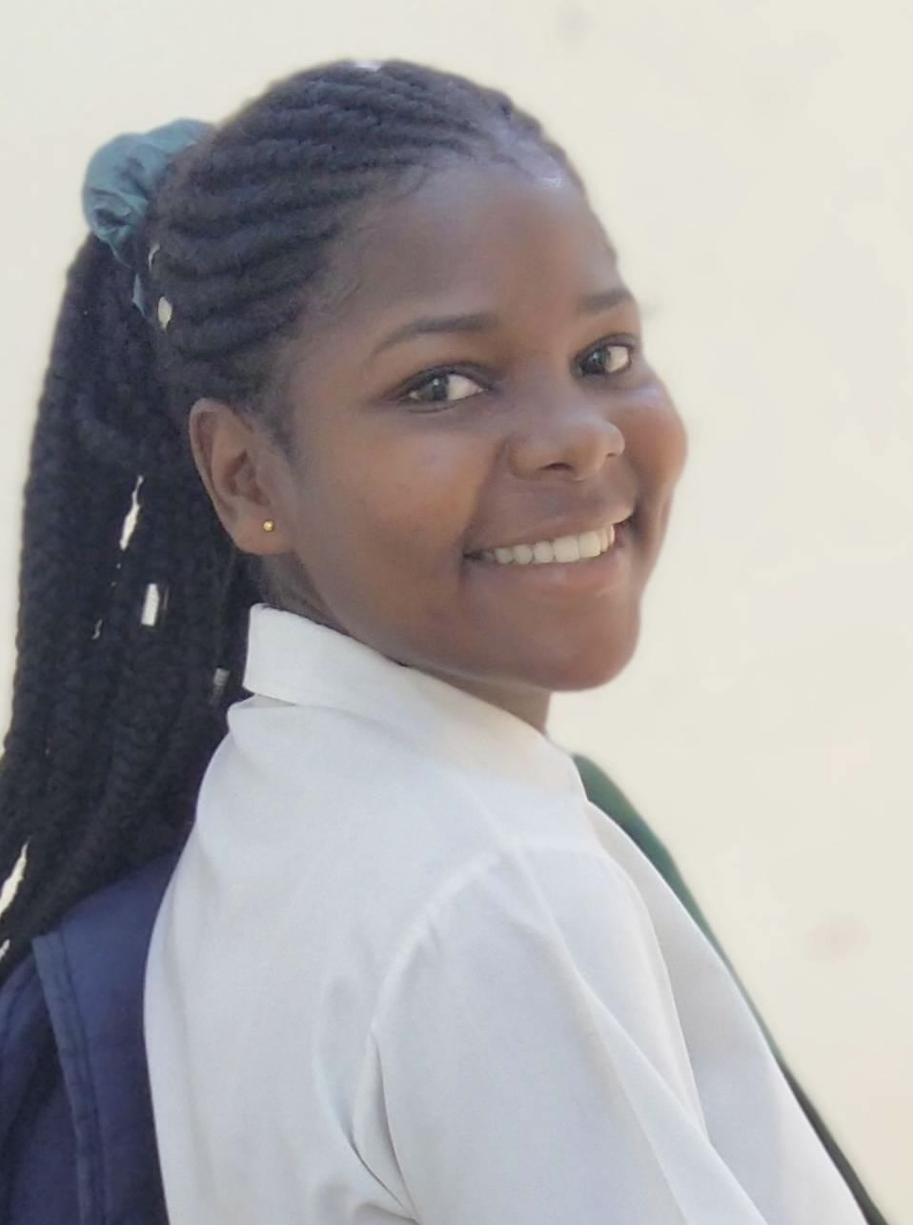
Additionally since our last report, Liana Estevão (left) has begun an accountancy degree program in Nampula, about five hours south of Pemba. Liana has been in our support program for about 12 years and is one of our brightest and most promising youth. Liana completed Grade 11 at the Iris Christian secondary school in December and is now finishing Grade 12 in Nampula along with her accountancy program.

Future Graduates

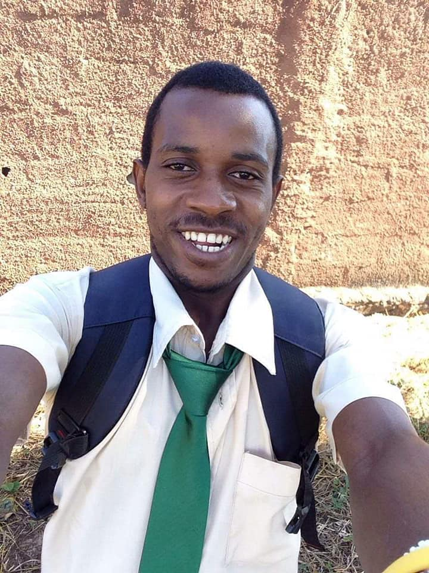
In the next few months, four of the young people we’ve been supporting since early childhood will complete university degree programs. Zaina Alide will complete her law degree. Baptista Gonçalves will graduate as a mechanical engineer. And Nando Bila (right) and Ferão Florencio (left) will graduate with education degrees in secondary school teaching of English. These are all notable achievements for fatherless youth who have come from the most poverty-stricken and disadvantaged backgrounds imaginable!

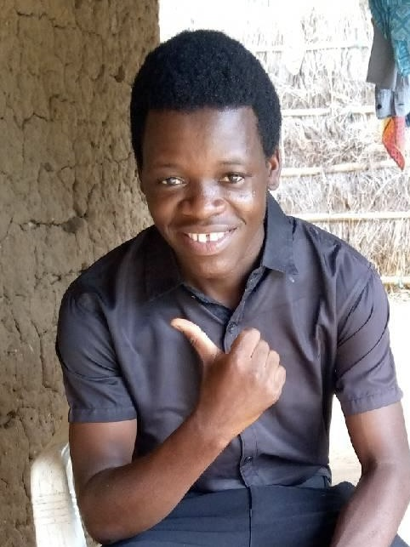

In August of last year, we registered two young women in the nursing program in Pemba. Marieta Selemane and Julia da Sabina have been successful in their studies to date and look forward to completing their program around the end of 2024. And in just a few weeks, four more young women will begin the 2-1/2 year nursing program: Aua Ahade (left below), Bendita Ribeiro, Ana Milo (middle) and Ancha Selemane (right).
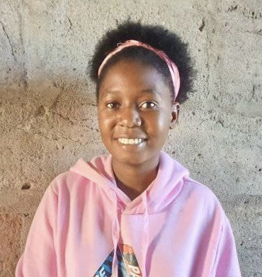

We are also currently supporting Gracinda Cassimo in the primary school teachers’ training program. Gracinda is doing very well in her challenging program and expects to graduate in about August of next year.

Our Other Long-Term University Students
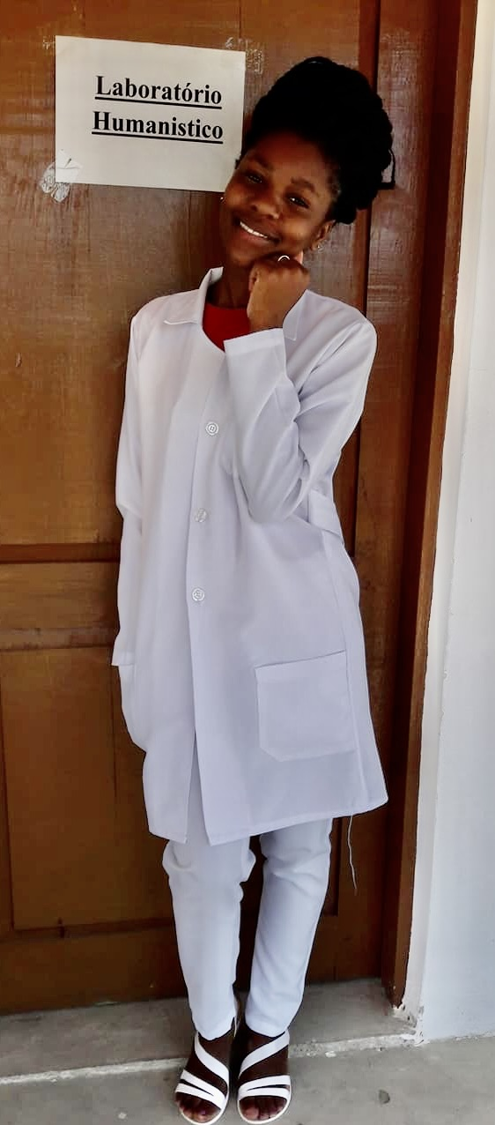
Three additional young women are midway through the 6-7 year program to become medical doctors: Telma Raimundo (left), Julia Siricate and Fernanda Manuel. Telma and Julia’s studies and practicum are now based at the large provincial hospital in Nampula. Fernanda, who is one year behind, is currently studying in Pemba but will relocate to Nampula later this year for the remaining years of her program.

Duration of our Sponsorship Program
By agreement with our two supporting Canadian charities, we anticipate that our support for these students and sponsored youth will continue through December 2025. By that time, all of the students referenced above should have completed their programs and we will not be initiating any further long-term program support which cannot reasonably be expected to be completed within that time-frame.

Sponsorships
Although we certainly welcome undesignated gifts—and even regular or occasional gifts toward my personal support—our ministry to children and their families is primarily based on your sponsorship support. Sponsors are paired with a child or children; and we will seek to double up the sponsorship of our older youth in post-secondary programs as more sponsors become available in order to increase the amount of monthly funding they receive.
Sponsorship support helps provide the basics of proper food and clothing and contributes to the costs of schooling. We also monitor the circumstances of our sponsored children to try to ensure their continued well-being. And we have high expectations for our sponsored children’s spiritual growth and for that of their families.

Contact Information: Sponsorships & Donations
Please feel free to email me if you want more information or are interested in becoming a sponsor: harvestinafrica@hotmail.com
All donations toward this work should be payable to Developing World Partnerships. They can be made via e-transfer using this email address: dwpdonor@gmail.com
or by cheques mailed to DWP at
82 St Clair Street, Summerside, PE C1N 0L2
Automatic monthly recurring donations for general purposes or for child sponsorship can be set up via Electronic Funds Transfer (EFT). Please contact me at my email above for further information.
Thank you for your prayers and support.
Blessings,
Don

